Multi-Label Classification

Gali Kiran Venkat

21BCE7369

*SCOPE*

*VIT-AP University*

*Amaravati,India*

*kiran.21bce7369@vitapstudent.ac.in*

***Abstract-*** Multi - label learning in content classification leverages understood relationships among related assignments to extricate common highlights and abdicate execution picks up. Be that as it may, most past works treat names of each assignment as free and insignificant one-hot vectors, which cause a misfortune of potential data and make it troublesome for these models to mutually learn three or more errands. In this paper, we propose Multi-Task Name Inserting to change over names in content classification into semantic vectors, in this manner turning the unique errands into vector-matching assignments. We actualize unsupervised, administered, and semi-supervised models of Multi- Task Name Implanting, all utilizing semantic relationships among assignments and making it especially helpful to scale and exchange as more assignments are included. In this paper, we have used three different approaches and a deep learning algorithm for the classification of multiple labels.

***Keywords-*** Multi-Label, Multi-task, classification,

semantic

I. INTRODUCTION

Multi-label classification finds common application in tasks such as sentiment analysis, topic categorization, and tagging reports with relevant keywords. In image classification, it proves valuable when a single image may encompass multiple objects or concepts. Bioinformatics employs multi-label classification for tasks such as protein function prediction, gene function prediction, and drug-target interaction prediction. Proposal systems utilize multi-label classification to anticipate various items or categories that a user may find interesting, such as in movie recommendation systems. Additionally, it plays a role in analyzing social media content for tasks like sentiment analysis, topic detection, and user profiling, given the diverse topics and multiple sentiments often expressed within social media posts. Multi-label classification is an important model to classify the labels in large datasets such as number of students studying in particular classes, the favorite political party of particular people, classifying the flora and fauna for research purposes and many more applications. E-commerce platforms use multi-label classification to automatically tag products with relevant categories and attributes. It can be used in environmental monitoring systems to classify sensor data into multiple categories such as air quality, water quality, and noise levels simultaneously. Multi-label classification allows for the modeling of complex relationships between data instances and multiple labels or categories. This is particularly useful in tasks where each instance may have relevance to multiple classes, such as document categorization, image tagging, and product classification. It can be applied across various domains and data types, including text, images, audio, biological sequences, sensor data, and more. This versatility enables its use in diverse fields such as natural language processing, computer vision, bioinformatics. Researchers and practitioners can customize and optimize multi-label classification algorithms to address specific challenges and requirements of different application domains. This includes handling label dependencies, class imbalances, and noisy data .The field of multi-label classification is actively evolving, with ongoing research efforts focused on developing new algorithms, improving performance metrics, and exploring novel applications and use cases. This continuous innovation expands the scope of multi-label classification and enhances its effectiveness in real-world scenarios.

The potential for multi-label classification is vast and continues to expand as new applications and domains emerge.

II. LITERATURE SURVEY

There have been numerous studies conducted on Multi - Label classification with different algorithms, which provide good accuracy rates and promising results. Here are some of the the notable works in the field:

[1] Collobert and Weston J 2020, makes use of a shared lookup layer for not unusual place features, accompanied with the aid of using venture-unique layers for numerous conventional NLP duties which include part-of-speech tagging and semantic parsing. They use a fix-length window to clear up the trouble of variable-duration enter sequences, which may be higher addressed with the aid of using RNN.

[2] Zhang, H.; Xiao, L.; Wang, Y.; and Jin Y. 2019 inspect multitask studying for textual content class and applies bag-of-phrase illustration and statistics of phrase orders are lost.

[3] Liu, Qiu, and Huang 2019 introduces an outside reminiscence for statistics sharing with a reading/writing mechanism for communications.

[4] Louis, P.; Smith T.; and Martha.2020. proposes 3 one-of-a-kind fashions for multitask studying with RNN and constructs a generalized structure for RNN primarily based totally multi-venture studying.

However, fashions of those papers forget about crucial statistics of labels and in general can simple cope with pair-clever interactions among duties. Their community systems are also fixed, thereby failing to scale or switch whilst new duties are involved. Different from the above works, our fashions map labels of textual content class duties into semantic vectors and offer a greater intuitive manner to recognize multi-venture studying with the capabilities of scaling and transferring. Input sequences from 3 or greater duties are at the same time discovered collectively with their labels, benefitting from every different and acquiring higher sequence representations.

III. PROPOSED WORK

*A. Details of the dataset*

The dataset used in this project is so_dataset_2_tags.

* It consists of random titles with particular tags associated with them.
* It also contains word frequency of that particular tags, like how many times that has repeated.
* The size of the dataset is 144 x 5.
* It is a simple dataset which is used for the multi-label text classification as there are lots of labels which are present in it.

*B. Technique*

To implement the novel framework for Multi- label classification, the following techniques can be used:

* Data Collection and Preprocessing: Data should be collected from various websites and tags should be associated with them. The collected data should be pre-processed to remove noise, artifacts, and irrelevant information, and to standardize the data.
* Machine Learning Model Selection: Various machine learning models such as Logistic regression, Naïve Bayes, KNN classifier can be used for the classification of labels. Here we transform multi-label problem into single-label problem(s) by using Binary Relevance, Classifier Chains, and Label Powerset. The selection of an appropriate model depends on the size of the dataset, complexity of the problem, and computational resources available.
* Model Training and Validation: The selected model can be trained and validated on the pre-processed dataset using appropriate techniques to ensure the accuracy and generalizability of the model.
* Model Evaluation: The trained model can be evaluated on a separate test set to measure its accuracy, sensitivity, and specificity for the label classification.
* Deployment: The trained model can be deployed in a real-world setting to support text classification in news aggregation, content moderation and filtering, financial risk assessment etc.

*C. Working Principle*

Generally there are two approaches in solving the multi- label classification problem. These are the two: problem transformation and adapted algorithm.

* Problem transformation refers to transforming the multi-label problem into single- label problem(s) by using Binary Relevance, Classifier Chains and Label Powerset.
* Binary Relevance treats each label as a separate single class classification
* In Classifier Chains , the first classifier is trained just on the input data and then each next classifier is trained on the input space and all the previous classifiers in the chain.
* In Label Powerset , we transform the problem into a multi-class problem with one multi- class classifier is trained on all unique label combinations found in the training data.
* In Adapted algorithms, some algorithms can be adapted for multi-label classification, such as k-nearest neighbors (k-NN), decision trees, random forests, and neural networks (e.g., with modifications like using the sigmoid activation function in the output layer for binary classification).
* After importing the dataset, we will be vectorizing the data so that machine can learn the data without much difficulty.
* We will be vectorizing the data using Tfidf Vectorizer which also calculates the term frequency of each word.
* After that, we will be using either of the above wo mentioned approaches to train the data and build the model for prediction.
* Once the model is trained, it can be used to make predictions on the labels classification..
* At the end, we will be calculating the accuracy and hamming score for the proposed model.

*D. Tools Used*

There are several popular toolboxes and libraries that can be used for multi-label classification. Some of these include:

* Scikit-multilearn: This is an extension of scikit-learn for multi-label classification. It provides a range of algorithms and tools specifically designed for multi-label classification tasks, including problem transformation methods like Binary Relevance, Classifier Chains, and Label Powerset.
* Numpy: NumPy is a fundamental package for scientific computing with Python. It provides support for large, multi-dimensional arrays and matrices, along with a collection of mathematical functions to operate on these arrays efficiently.
* Pandas :Pandas is a powerful data manipulation and analysis library built on top of NumPy. It offers data structures like Data Frame and Series, which allow for easy handling and manipulation of tabular data.
* Neattext: Neattext is a Python library designed to clean and preprocess text data efficiently. It offers a range of functionalities for text preprocessing, normalization, and transformation, making it easier to prepare text data for further analysis or machine-learning tasks.

*E. Flowchart*

Below is the flow of the data and gives a brief idea about how the model works in classifying the multi-labels using the two approaches: Problem transformation and Adapting algorithms.

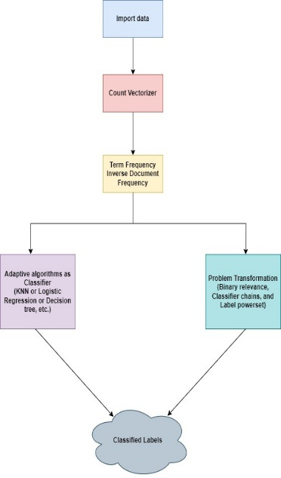

*Figure-1*: Data Flow Diagram

V. RESULTS AND DISCUSSIONS

*A. Output*

Intial rows of the dataset

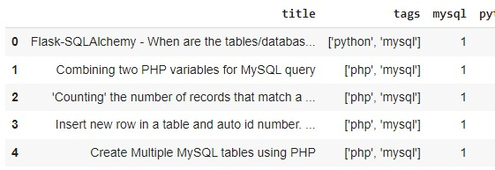

Extracting stopwords

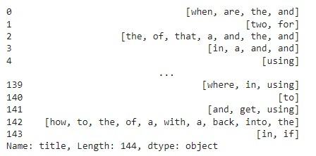

Removing the stopwords

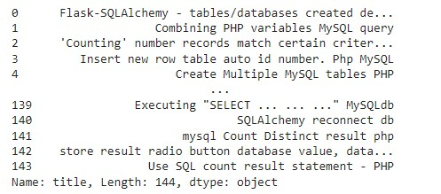

X features after applying Tfidf Vectorizer

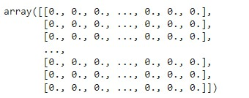

Count plot of python

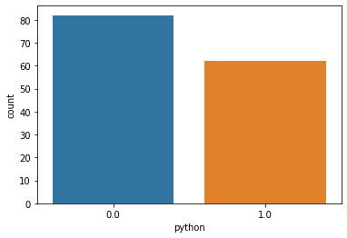

Count plot of php

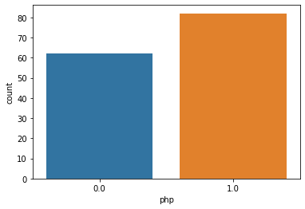

Binary relevance using Naiive Bayes as a classifier:

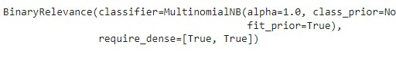

Predicted values using Binary relevance

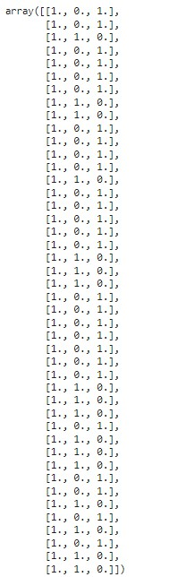

Here we can observe the accuracies and hamming loss of all the three proposed methods:

|  |  |  |
| --- | --- | --- |
| Approach | Accuracy | Hamming Loss |
| Binary Relevance | 0.909090901 | 0.060606061 |
| Classifier Chains | 0.060606061 | 0.106060606 |
| Label Powerset | 0.909090901 | 0.060606061 |
| CNN | 0.871000005 | 0.087300001 |

*Table-1:* Comparing metrics

Here we can observe that the methods like Binary Relevance and Label Powerset are having a very good accuracy than that of the Classifier Chains. These methods also having good accuracy compared to the CNN approach.

Picking a sentence from the dataset to predict labels



Prediction:



Here, leftmost 1. Is mySQL, middle 1. is python and 0. Is php. mySQL and Python were classified as 1 because they are the tags for the given sentence in the dataset whereas php is not present in the first sentence tags that’s why it is marked as 0.

*B. Formulae*

Here we use performance metrics such as **accuracy** and **hamming loss**, which are utilized to evaluate our model with the proposed methodology because accuracy alone can’t decide the model correctness.

**1) Accuracy** is the ratio of number of correctly predicted samples to the total number of samples. The following equation can be used to calculate accuracy:

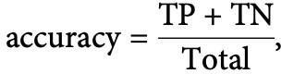

where TP and TN denote the number of true positives and true negatives, respectively.

**2) Hamming loss** is a metric used to evaluate the accuracy of multilabel classification algorithms. It measures the fraction of labels that are incorrectly predicted. This metric is particularly useful when dealing with datasets where each sample can belong to multiple classes simultaneously. The following equation can be used to calculate hamming loss:



where N is the number of samples. ∣L∣ is the number of labels. yij is the true value j-th label for the i-th sample. y(cap)ij is the predicted value of the j-th label for i-th sample. XOR is the exclusive function, which returns 1 if the input differs, and 0 otherwise.

CONCLUSION

This paper presents multi-label classification with some approaches to give the proper classification results. This type of classification is used to classify the labels in the larger datasets. In order to see, we have used the algorithms and successfully predicted the labels given in the dataset with higher accuracy than that of the approach used in the base paper.

FUTURE WORK

Future work in multi-label classification is likely to focus on developing methods to model and exploit dependencies between labels effectively can improve the accuracy of multi-label classification models. Exploring the application of multi-label classification techniques in emerging domains such as autonomous driving, personalized medicine, smart cities, and Internet of Things (IoT) can uncover new opportunities and challenges. Research in these areas could lead to novel applications and use cases for multi-label classification.

REFERENCES

[1] Collobert, R., and Weston, J.2020. A bound together design for common dialect handling: profound neural systems with multitask learning.

[2] Zhang, H.; Xiao, L.; Wang, Y.; and Jin,Y. 2019. A generalized repetitive neural engineering for content classification with multi- task learning.

[3] Liu, P.; Qiu, X.; and Huang, X.2019. Profound Multi-Task Learning with Shared Memory for Content Classification.

[4] Louis, P.; Smith T.; and Martha.2020. Repetitive Neural Organize for Content Classification with Multi-Task Learning.

[5] Ozan Sener and Vladlen Koltun, "Multi-Task Learning as Multi-Objective Optimization",2019.

[6] Teresa M.A. Basile, Nicola Di Mauro, and Floriana Esposito, "Extremely Randomized CNets for Multi-label Classification",2023.

[7] Jingcheng Du, Qingyu Chen, , and Zhiyong Lu, "ML-Net: multi-label classification of biomedical texts with deep neural networks",2018.

[8] Jack Lanchantin, Tianlu Wang, Vicente Ordonez, and Yanjun Qi, "General Multi-label Image Classification with Transformers",2021.

[9] Elijah Cole, Oisin Mac Aodha, , and Nebojsa Jojic, "Multi-Label Learning from Single Positive Labels",2021.

[10] Jiang Wang, Yi Yang, Junhua Mao, Zhiheng Huang, Chang Huang, and Wei Xu, "CNN-RNN: A Unified Framework for Multi-label Image Classification",2016.